Stock.txt(data)
Pilot_Pens
400
1.39
.75
No._2_Pencils
1000
.25
.1
Notebooks
500
6.99
3.47
ColRl_100Sht.
150
1.59
.89
GraphP_50Sht.
50
4.59
1.23
Desk_Lamp
12
45.00
18.00
Port.Telephone
25
189.99
100.00

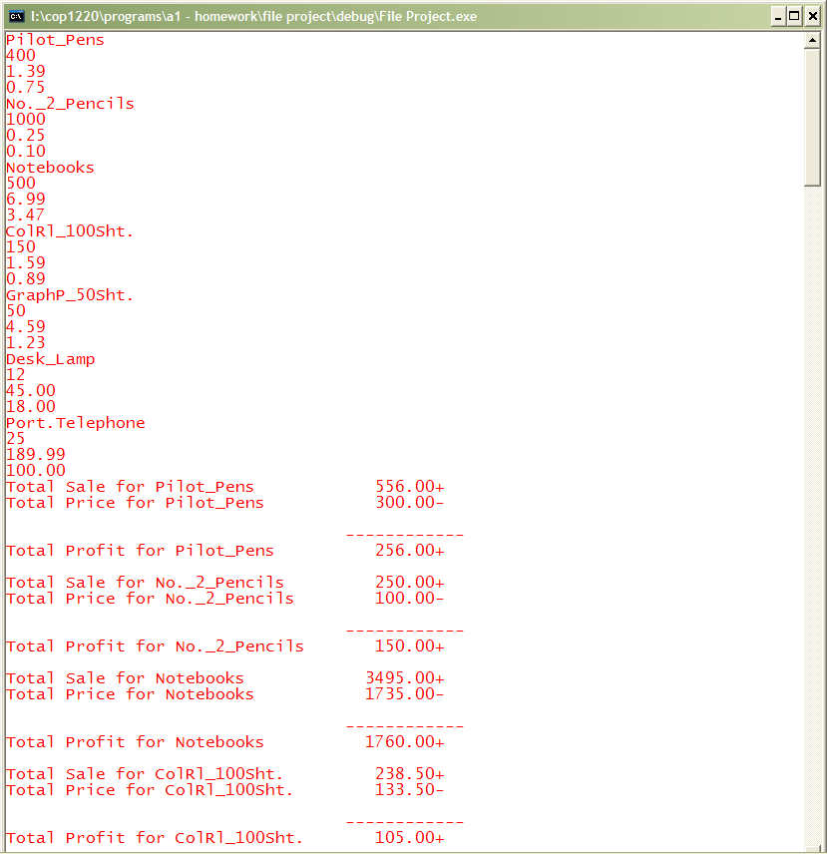
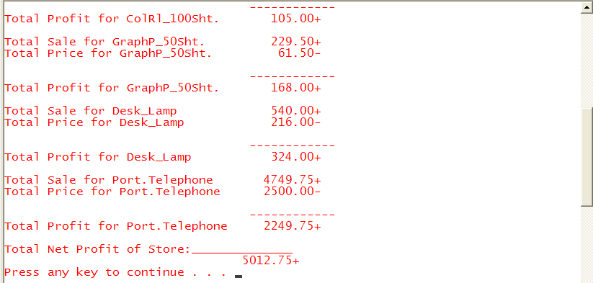

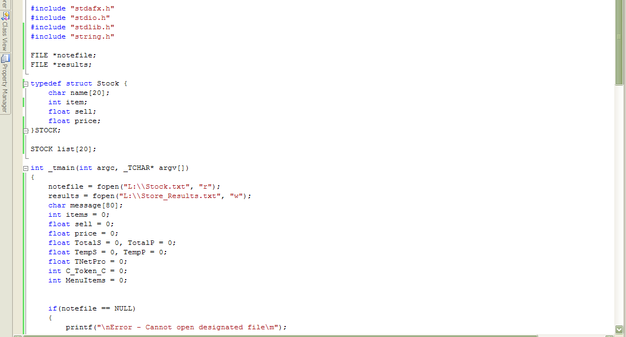
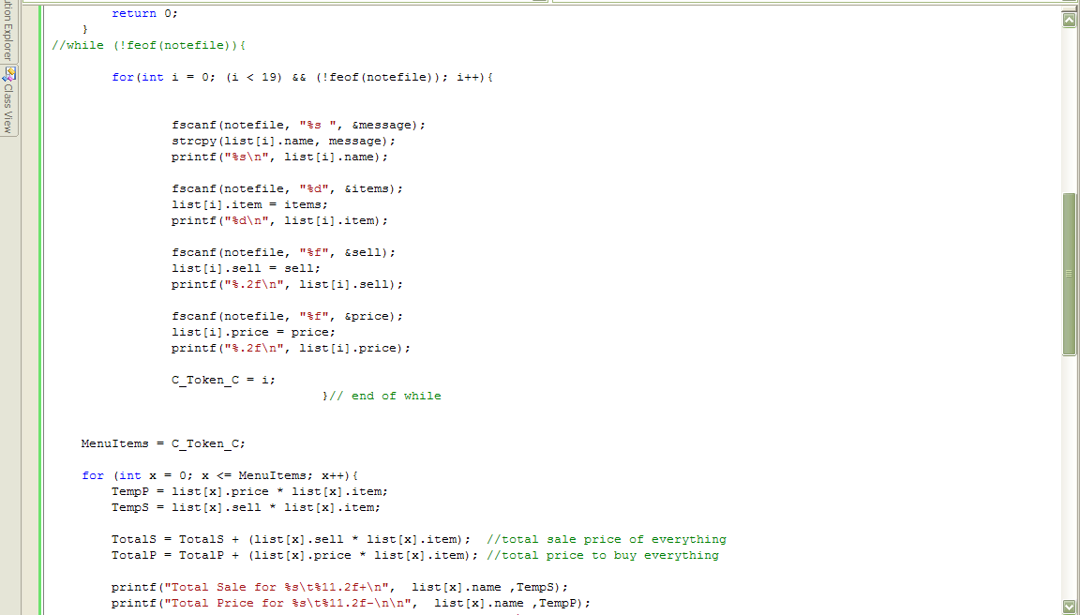
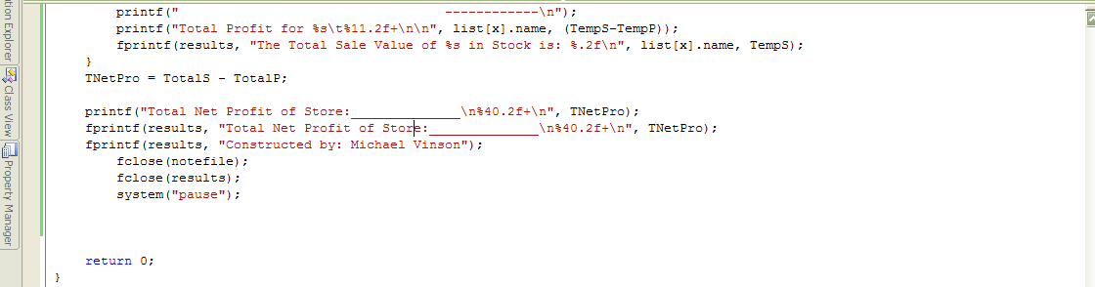

Result.txt(data)
The Total Sale Value of Pilot_Pens in Stock is: 556.00
The Total Sale Value of No._2_Pencils in Stock is: 250.00
The Total Sale Value of Notebooks in Stock is: 3495.00
The Total Sale Value of ColRl_100Sht. in Stock is: 238.50
The Total Sale Value of GraphP_50Sht. in Stock is: 229.50
The Total Sale Value of Desk_Lamp in Stock is: 540.00
The Total Sale Value of Port.Telephone in Stock is: 4749.75
Total Net Profit of Store:______________
5012.75+
Constructed by: Michael Vinson

